Git basics Assignment 1 - Day1

- Repo setup

- Initialize a new Git repository using
We will first create a folder and open it in VS Code. Then we will use the command “git init” to initialize a new git repository.
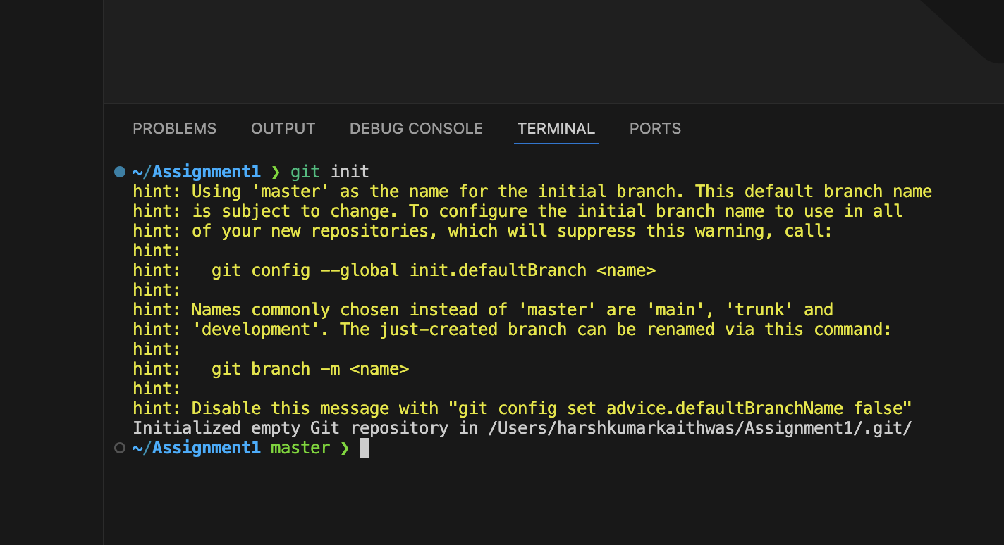

- Configure your local name and email into the new repository
To do this we will use the commands:

“ git config user.name "harsh kumar kaithwas" and
“ git config user.email "hkaithwas@ancilar.com"

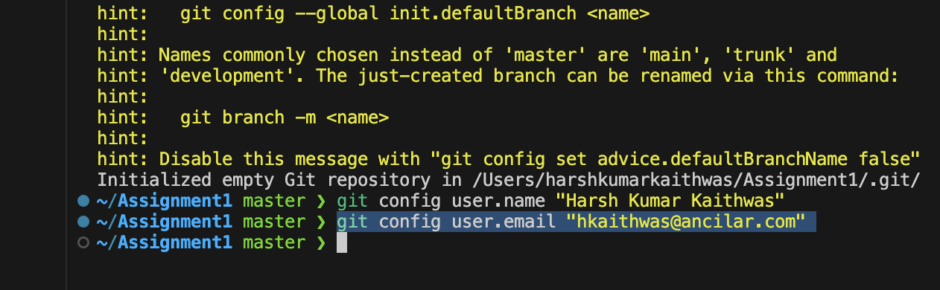

- Connect your local repository to a GitHub remote and verify the connection
First create a new repository
Then navigate to your local repository
Then use command “git remote add origin <link_of_repo>”

To verify the connection use: git remote -v

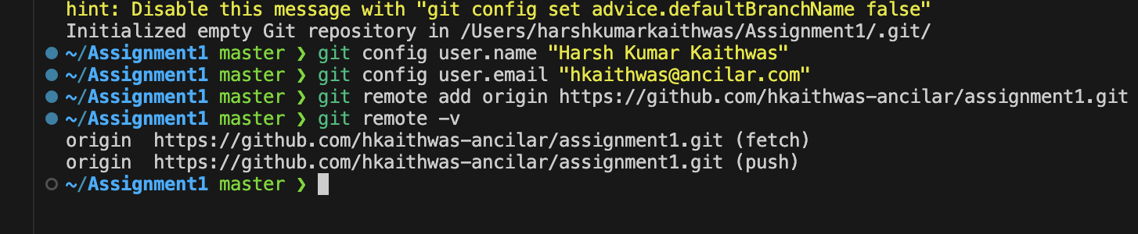

Query: Why is Git considered one of the most popular version control systems in the industry?

Answer - Git is an open source VCS which is fast and scalable. Software developers prefer Git over other VCS like CVS, Mercurial and Perforce because of adaptability, speed and stability.

2. Working with Files and Commits

- Create a new file, add it to staging and commit it.

Create a new file
To put it into staging area we use - git add <file_name>
To commit it - git commit -m “new file”

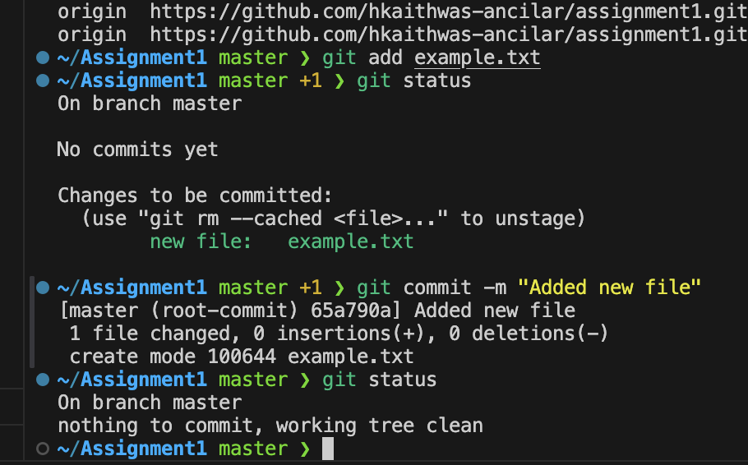

- Modify the file and explore the changes.
Add some text to the file
Then :
git status
git diff

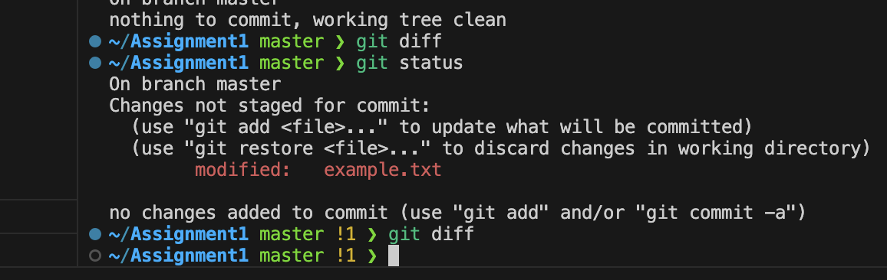

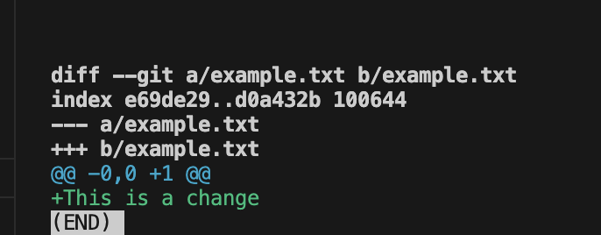

- View the commit history (try with options like --oneline, --graph).

For commit history - git log
Using oneline - git log --oneline
Using graph as well - git log --oneline --graph
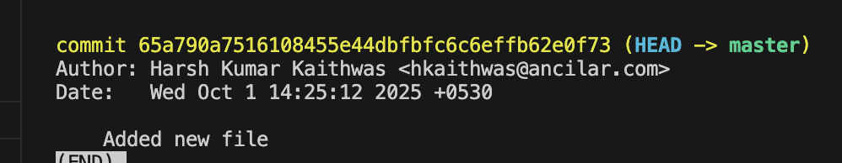

Output would be the same for online and graph as we have added only
one file:
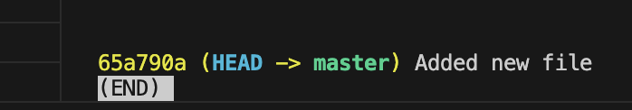

Query: What is a SHA hash in Git, and why is it important?
Answer -
In Git, a SHA hash is a unique string of letters and numbers that acts like a digital fingerprint for each commit or file. SHA stands for Secure Hash Algorithm, and Git uses SHA-1, which is a long string of letters and numbers, something like: e1a1b5f2c3d4e6f7g8rf356ge63728hvgwy67hfvt56
It helps Git identify and track every change in your project. Even a tiny change creates a new SHA, so Git can ensure nothing is changed.

3. Understanding Remote Operations

- Clone any public repository from GitHub.
Get any public repo and copy its URL
Then use - git clone <link_of_repo>
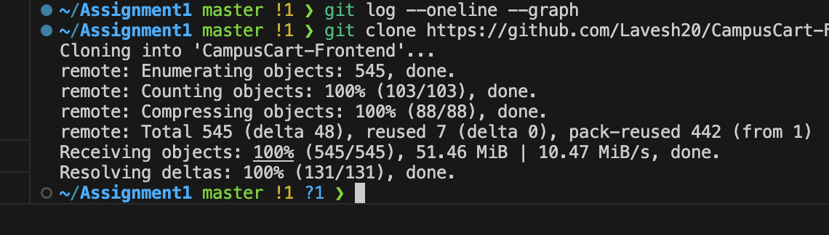

- Experiment with git fetch to see how it differs from git pull.
Navigate to repo
Check branch
Use command - git fetch
See changes - git log <branch>

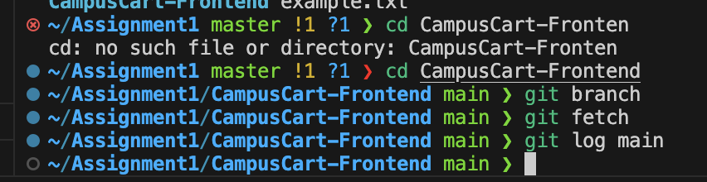
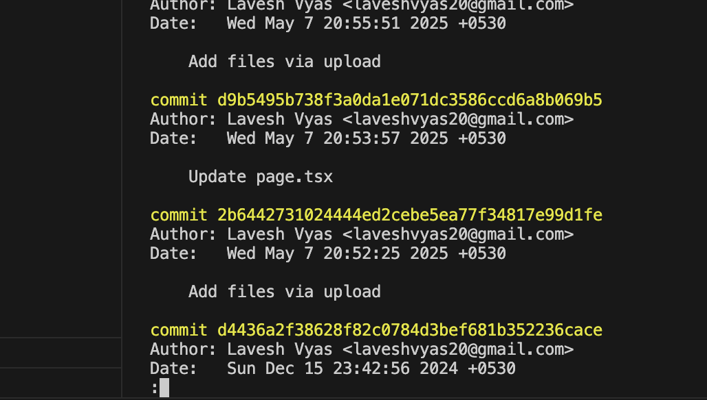
- git pull will merge the changes into the local branch
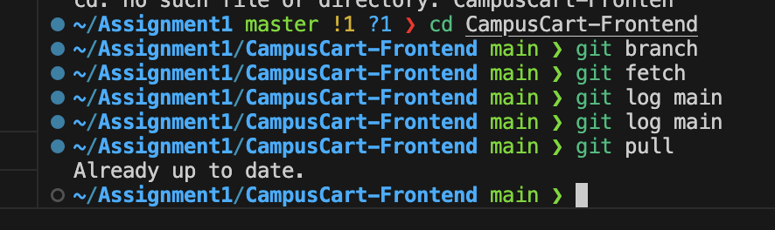

- Push your local commits to the remote.
Steps -
- git add .
- git commit -m “New commit”
- git push origin main

Query: What is the key difference between git fetch and git pull?
Answer -
Git fetch downloads the latest changes from the remote repository but does not change your local files.
Git pull downloads the changes and automatically merges them into your local branch.

4. Commit Lifecycle & Modification

- Make a new change to a file, add it, then undo the staging:
Create a new file
Use - git add <file_name>
Use - git reset <file_name> (this will undo the staging)

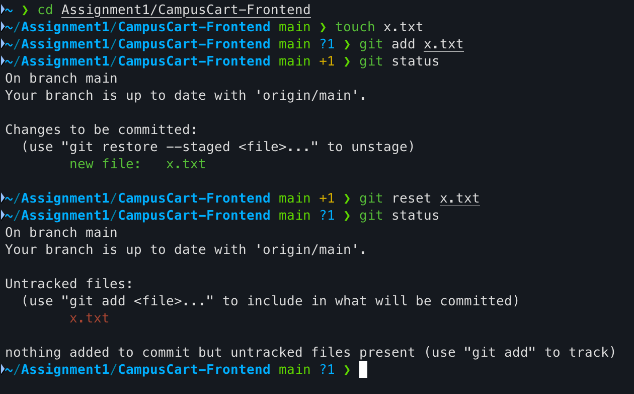

- Remove a file from your repository and commit the change:
Use rm command - rm <file_name>
Commit it - git commit -m “file removed”
Push changes - git push origin main

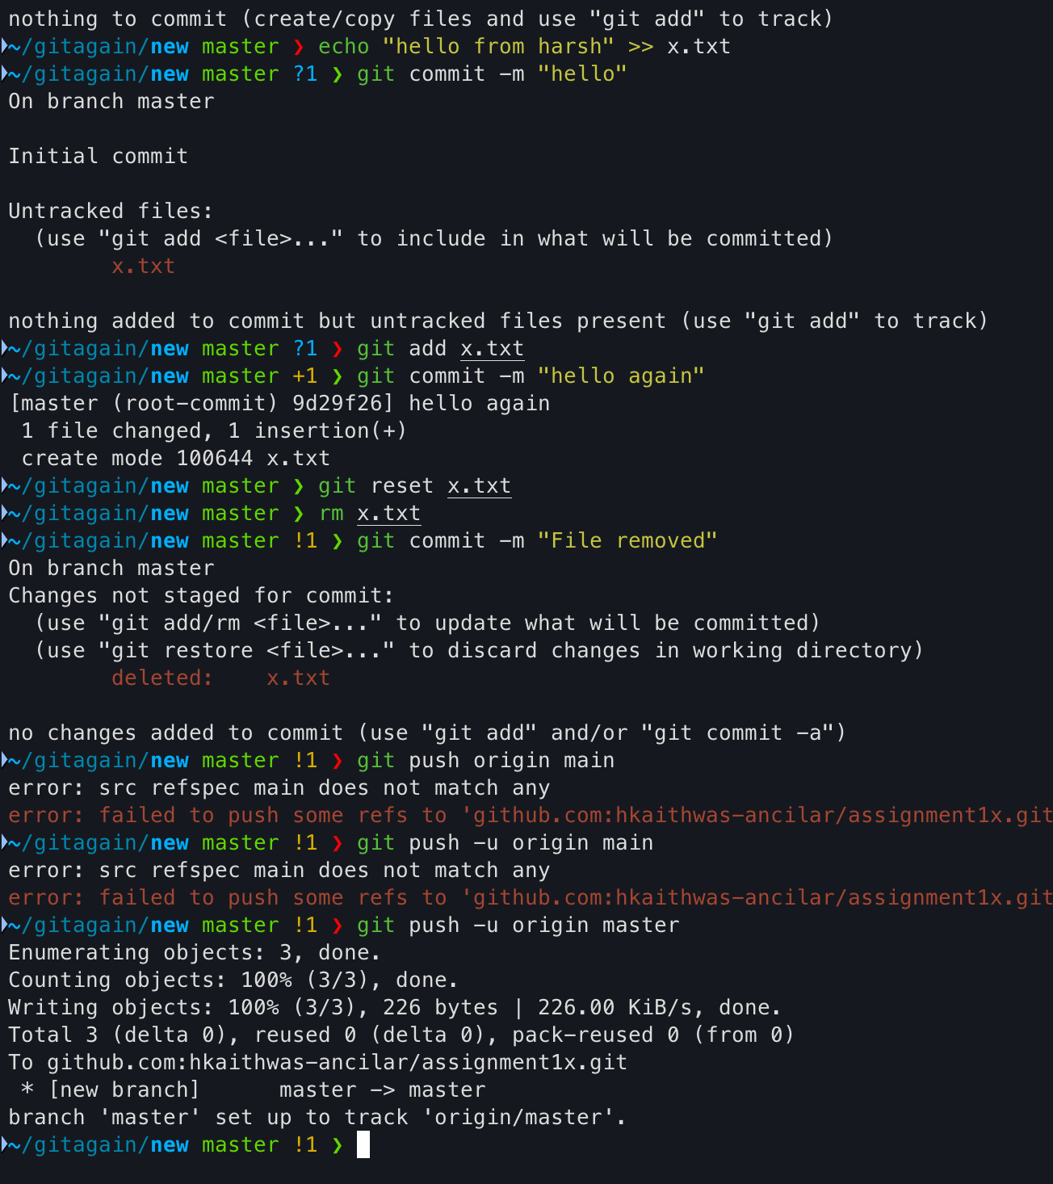

- Make a commit, then change the commit message
We can use - - amend command
Add a file - git add y.txt
Commit - git commit -m “new file added”
Use amend - git commit - - amend -m “new updated message”
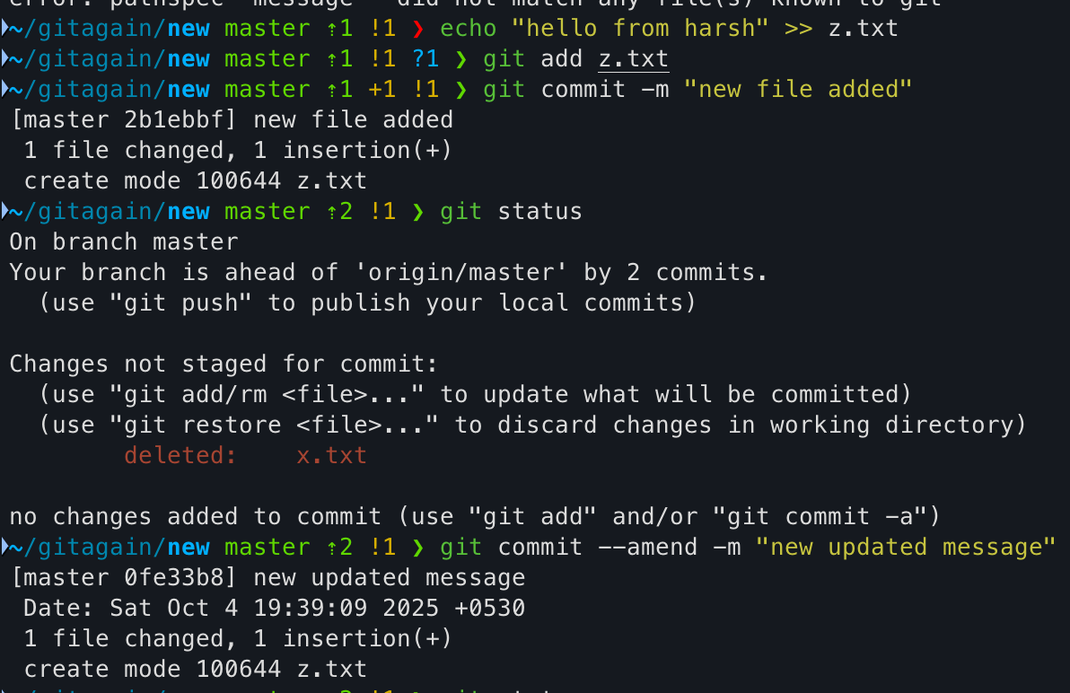

Query: How does git reset differ from git rm?
Answer -
Git reset is used to undo the staging or move the branch pointer back, but it does not delete files.
Git rm is used to remove files from the repository and optionally from your local folder.

5. Advanced Operations
- Temporarily save uncommitted changes and then restore them
save uncommitted changes - git stash
restore them - git stash pop
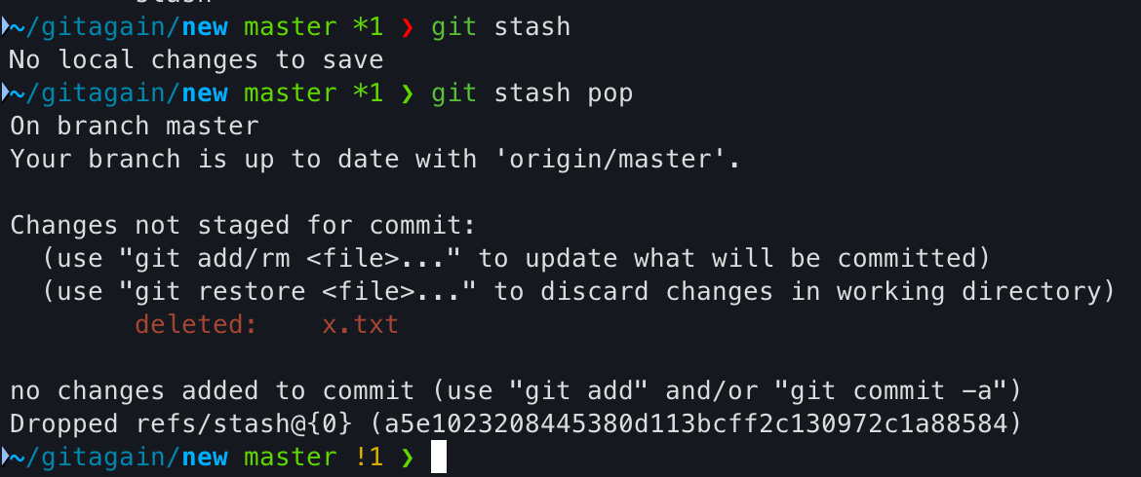
- Revert a commit.(observe how it creates a new commit instead of deleting history).
Add a new file and a commit message
echo "New file" >> file.txt
git add file.txt
git commit -m "added new file”
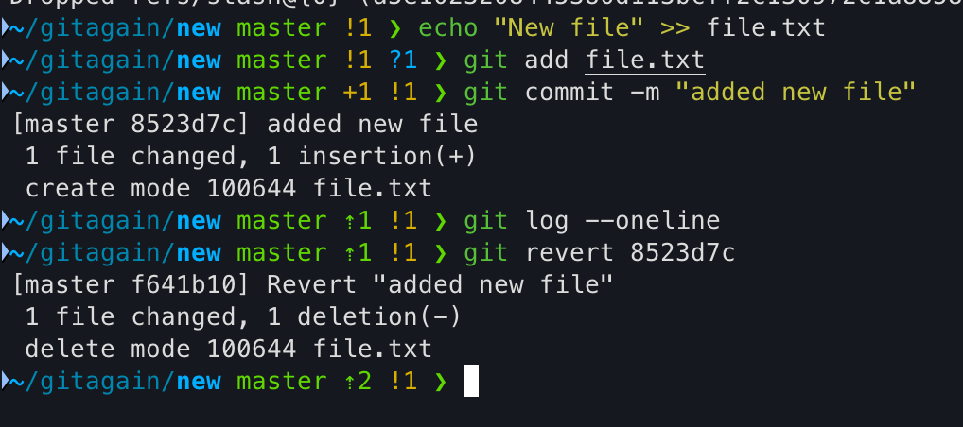
Get the commit UID from - git log --oneline
Then - git revert 8523d7c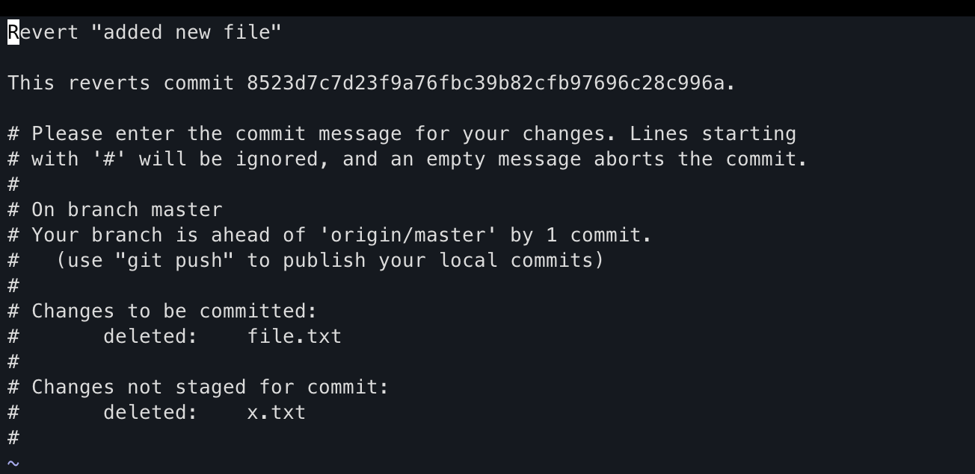

Query: How does Git calculate file differences when using commands like git diff? (Hint: HEAD)
Answer -
git diff is a function that takes two input data sets and outputs the changes between them. It uses HEAD’s of commits to work. git diff is a multi-use git command that when executed runs a diff function on git data sources. These data sources can be commits, branches, files etc.

